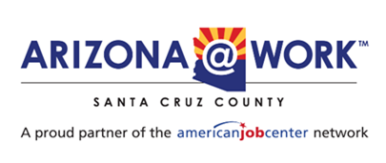

**Santa Cruz County Local Workforce Development Board**

**Agenda**

**Wednesday, January 22nd, 2025 12:00 pm – 1:30 pm**

**Santa Cruz County Administrative Complex**

**2150 N. Congress Drive, Court Room A**

**Nogales, AZ 85621**

Zoom link: <https://us02web.zoom.us/j/89490073656?pwd=PSkxUqIMjxw6q5srVruhYHuRSfLdsO.1>

1. Call to order
2. Pledge of Allegiance
3. Roll call
4. Call to the public
5. Adoption of Meeting Minutes- November 20th, 2024 Regular Board Meeting
6. Budget Report- Finance Department
7. Strategic Planning- Execution of Services in Collaboration with the LWDB members
8. Board Recertification
   1. 6 total vacancies (120 days to fill vacancies from 11/20/2024)
      1. 4 business representatives
      2. 2 workforce representatives
9. Presentation from - Francisco Padilla, Regional Director, First Things First: When Child Care Works
   1. Supportive Services Policy
10. Interplay Learning- Virtual Reality: Construction Trades
11. Future Trainings & Conferences
    1. WIOA Title I-B 101 training
       1. Will be provided by WIOA Policy team
    2. National Association of Workforce Boards (NAWB) March 29- April 1
    3. National Association of Workforce Development Professionals (NAWDP) Virginia Beach, VA., May 5- May 7
    4. Council for Adult and Experiential Learning (CAEL) Memphis, TN., November 11-14
12. Questions on Board Report (Title I-B, Title II, Title III, Title IV, WIOA Title ID (MSFW), Fred G. Acosta, Job Corps (Partner Program), One Stop Operator
13. Roundtable
14. Next meeting- March 12, 2025