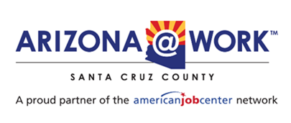

**Santa Cruz County Local Workforce Development Board**

**Agenda**

Wednesday, April 9, 2025

Santa Cruz County Administrative Complex

2150 N. Congress Drive, Courtroom A

Nogales, AZ 85621

<https://us02web.zoom.us/j/89490073656?pwd=PSkxUqIMjxw6q5srVruhYHuRSfLdsO.1>

1. Call to order
2. Pledge of Allegiance
3. Roll call
4. Call to the public
5. Adoption of Meeting Minutes January 22, 2025
6. Budget Report- Finance Department
7. National Association of Workforce Board (NAWB) Forum 2025 Recap
8. Quality Assurance and Integrity Administration (QAIA) Audit
   1. Received notification of audit March 13
   2. Audit complete and accepted on April 3
9. WIOA Guidelines and Procedures
10. Rapid Response Policy due by end of May
11. Rapid Response – affected employers
12. Rio Rico Medical Fire June 14- August 23 EMT Academy
13. Meeting with Carlos Contreras, Director for Office of Economic Opportunity
    1. Roundtable discussion around economic and workforce challenges/ successes
    2. Fresh Produce Association, South32, Santa Cruz County Provisional Community College, Mariposa Community Healthcare, Arizona Department of Economic Security, WIOA, Adult Education
    3. Office of Economic Opportunity will be offering SCC LWDB an in-depth training into allocations and eligibility- coordinating logistics
14. Strategic Planning request update
15. Questions on Partner Reports (Title I-B, Title II, Title III, Title IV, WIOA Title ID (MSFW), Fred G. Acosta, Job Corps (Partner Program), One Stop Operator
16. Roundtable
17. Next meeting- May 14, 2025