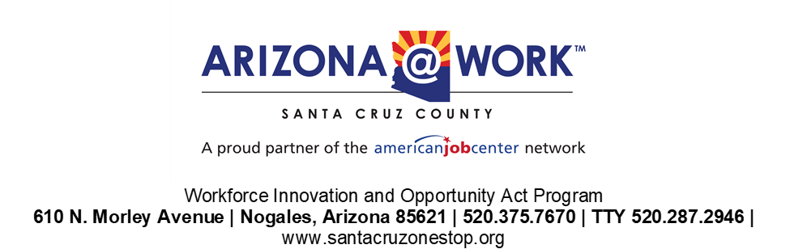

AMENDED 05/12/2025

**Special Meeting Agenda**

**May 13, 2025, at 3:30 PM**

**Virtual**

<https://us02web.zoom.us/j/84769972408?pwd=hbUvQQCE35dgbqKU9SNbYGF5VYNQip.1>

Meeting ID: 847 6997 2408   
Passcode: 732841

1. Call to order
2. Roll call
3. Approval of agenda
4. Discussion/ Possible action to approve the Santa Cruz County LWDA Rapid Response policy as stated in the Workforce Innovation and Opportunity Act (WIOA) Rapid Response Policy Chapter 2- Section 900.
5. Discussion/ possible action to approve Memorandum of Understanding: Circles of Peace: BRIDGE Coalition
6. Questions/ Feedback
7. Adjournment