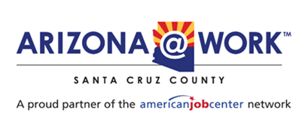
Santa Cruz County Partner Reports
June 25, 2025, LWDB Meeting

Title I: WIOA
WIOA Title I continues its outreach efforts by attending informational events and networking with other One Stops. Interest in the CDL program remains strong, though there has been a noticeable increase in demand for trade certifications such as HVAC, Electric, and Welding. Additionally, many participants are pursuing healthcare certifications, including medical assistant, billing and coding, pharmacy tech, LPN, and physical therapy. Other in-demand certifications that clients seek are anything in Information Technology, such as cybersecurity, CompTIA, IT Support Specialist, and IT Support Technician.
Adults enrolled in training 50
Dislocated Workers enrolled in training 7
Youth enrolled in training or receiving individualized career services 24
*PY 24 July 1, 2025- June 30, 2025*
Title II: Adult Ed
Enrollment:
Goal ABE: 160, Current: 67
Goal ESOL: 240, Current: 239

Progress Exam Test Rate:
State is at 53%
Currently we’re at 43%

Progress Exam Success Rate:
State is at 59 %
Currently we’re at 50%

Comments:
On May 30th, the Santa Cruz County Adult Education Program celebrated the accomplishments of 21 High School Equivalency graduates and 7 English as a Second Language Program graduates during our annual graduation ceremony. Held in partnership with the Santa Cruz Center and proudly supported by the Santa Cruz County School Superintendent’s Office and the Arizona Department of Education, the event highlighted the transformative power of adult education. Many of our graduates have balanced jobs, families, and other responsibilities while working toward their goals, and several have already enrolled in college or are preparing to enter the workforce. We are especially grateful to South32 for their sponsorship and continued support of adult learners in our community.

Title III: Employment Services
April 1 to June 6
Staff assisted registrations | 275
Average age | 43
Total Services Provided | 3,876
Job referral from AJC | 111
WIOA Referrals to Title I | 2
Job Placements | 26

Title IV: Vocational Rehabilitation
Program overview:
Vocational Rehabilitation Services (VR) uses a hybrid model for delivering quality services to job seekers. VR staff are actively working in the community (field) and in the VR office each week, meeting with clients in person or virtually, depending on the client’s choice. VR Counselors will be scheduled in the office at a minimum of two days per week and/ or work in the field with job seekers.
The Nogales VR office has a bilingual professional team composed of two VR Counselors (VRC) and a Rehabilitation Technician (RT) who serve job seekers who have documented disabilities (physical and/ or cognitive) and are needing assistance finding and maintaining competitive integrated employment in Santa Cruz County.

The second VR Counselor is very new and has not been a part of the current FY data. Intrinsically, the Nogales office has had one working VR Counselor this FY serving our job seekers locally, until we could get another VR counselor hired and trained.
--------------------------------------------------------------------------------------------------------------
Data search: 7/1/2024 – 06/11/2025
Nogales
- New Referrals: 73
- Compared to last year with the same date range: 81
- Number of Individualized Plans of Employment completed with job seekers with chosen vocational goal: 24
- Compared to last year with the same date range: 40
- Exits with employment/ successful closures: 14
- Compared to last year with the same date range: 11
Note: The above numbers were generated by filtering VR’s internal data management system and cross-checking internal tracking systems.

- Highlights:

- The Nogales office has met its FY goal in the number of Exits with Employment!
- Vocational Rehabilitation has a new database system launching July 2nd, 2025 called ‘InFormed’.
- Sonoran UCEDD Summer Work Program in partnership with Vocational Rehabilitation Services (Pre-ETS Special Projects) is for school-aged youth seeking paid summertime employment. We are currently underway with students enrolled from Pima County, for the first time in Cochise County and for the third year in a row from Santa Cruz County this summer.
- The Customized Employment pilot project in partnership with Vocational Rehabilitation continues in the Nogales area with one high needs job seeker. Customized Employment is for Job seekers with significant disabilities who have not been or who are unlikely to be successful with traditional, demand-side employment. This pilot is being overseen by the University of Arizona’s Sonoran Center for Excellence in Disabilities. In Region II, we have started in Tucson and in Nogales with launching this pilot.

- Cross referrals with AZ@Work (Titles I, II, III & IV) –
Titles can share information by asking mutually enrolled clients to sign Releases of Information (ROIs), allowing the Title partners to share specific program updates concerning the client.

Fred G. Acosta Job Corp

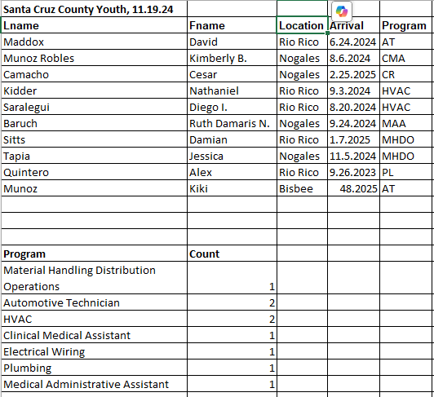
One Stop Operator
Zaida and I continue to talk on a regular basis. I attended three of the Business Services Reps' weekly meetings. Business Services team meetings. One new WARN in Phoenix. The second round of funding of one million dollars for the apprenticeship program was awarded by the State. The State has set a goal of reaching one million apprentices by the end of the year. Finance and Insurance is the sector of the month. These are the principal activities of finance and insurance.
1. Financial intermediation
2. Pooling of risks
3. Providing specialized services
February 2024 through February 2025 saw a net gain of 3,800 jobs in total employment. Finance and insurance lost 100 jobs. Insurance carriers lost 400 jobs. Finance and Insurance are projected to gain 959 jobs between 2024 -2026. Total employment is expected to increase by 14,000 jobs between 2023 and 2033.
Training outcomes showed 75% job retention for those that went through training, 4 quarters after completion.
In the second week we discussed barriers to employment as it relates to job fairs. No Shows was the biggest barrier mentioned. The group is going to accentuate follow-up with attendees to see if this has a positive impact on employment.
Mohave, La Paz is going to high schools six months prior to graduation to see if this helps with recruiting.
There was one new WARN in the third week of the meetings. It was the Florence Immigrant and Refugee Project. It affected 47 federal employees.
Payson is looking for caregivers. A travel stop in Winslow is looking for 60-90 people.
It was reported that there is a job fair being held all over the state. It appears there are lots of job opportunities and lots of employers looking for clients.
Held monthly Partner meeting.
Adrian and I were the only two who attended. We discussed having the next partner meeting in person. We suggest that the next meeting be held the same day as the June Board meeting. I will reach out to

