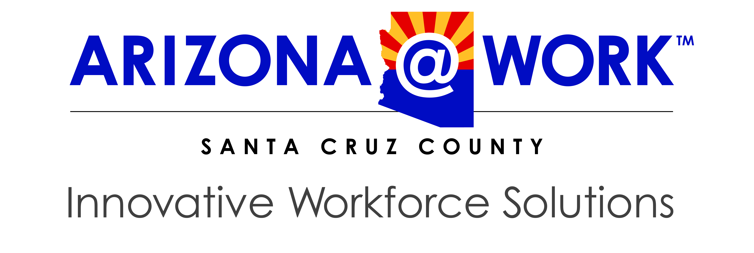

Santa Cruz County Workforce Development Board
Agenda

Wednesday, March 10, 2021 / 12:00 pm – 1:00 pm
Via Zoom
610 N Morley Ave

- Call to Order

- Pledge of Allegiance

- Roll Call

- Call to the Public

- Adoption of Meeting Minutes – January 13, 2021

- Introductions – New Members

- Partner Reports
  - Title I – Workforce Development
  - Title II – Adult Education & Literacy
  - Title III – Wagner-Peyser Act / Employment Services
  - Title IV – Vocational Rehabilitation Services

- One Stop Operator – Report
- Presentation – “WIOA Local Workforce Development Board 101”
- Nomination Process
- Board Reports

- Next Meeting – Wednesday, May 12, 2021

- Adjournment

An Equal Opportunity Employer. Auxiliary aids and services are available upon request to individuals with disabilities.
Services are made available through federal funding provided by the Workforce Innovation and Opportunity Act.

