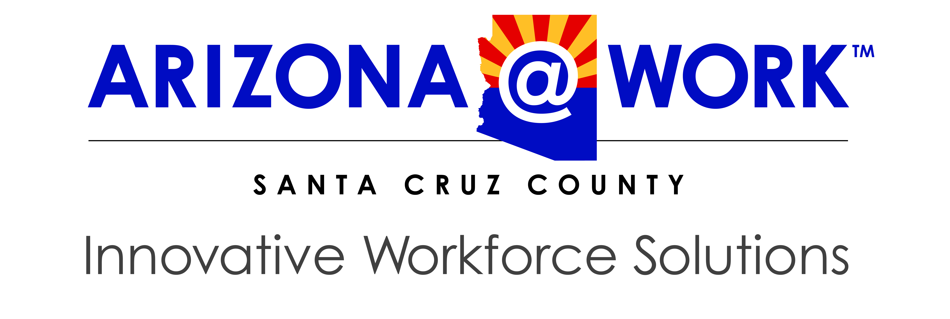

Santa Cruz County Workforce Development Board
Agenda

Wednesday, May 12, 2021 / 12:00 pm – 1:00 pm
Via Zoom
610 N Morley Ave

- Call to Order

- Pledge of Allegiance

- Roll Call

- Call to the Public

- Adoption of Meeting Minutes – March 10, 2021

- Election Results

- Presentation – Disabled Veteran Outreach Program (Xavier Pelaez, Kristy Prather, Miguel Ramos)
- Partner Reports
  - Title I – Workforce Development
  - Title II – Adult Education & Literacy
  - Title III – Wagner-Peyser Act / Employment Services
  - Title IV – Vocational Rehabilitation Services

- One Stop Operator – Report
- Board Reports

- Next Meeting – Wednesday, July 14, 2021

- Adjournment

An Equal Opportunity Employer. Auxiliary aids and services are available upon request to individuals with disabilities.
Services are made available through federal funding provided by the Workforce Innovation and Opportunity Act.

