SANTA CRUZ COUNTY
WORKFORCE INNOVATION AND OPPORTUNITY ACT
LOCAL WORKFORCE DEVELOPMENT BOARD MEETING
VIA ZOOM MEETING

March 10, 2021 Minutes

Board Members Present Via Zoom Board Members Absent
Victor Cardenas Arnold Quijada
Louie Doyle Sammy Legleu
Dan Doyle Ramses Giron
Dina Rojas-Sanchez Dr. Stella Perez
Olivia Ainza-Kramer Abraham Sneed
Tom McAlpin Christopher Young
Maria E. Kinder Raquel Espinoza
Karen King Victor Hetherington
Nora Herrera Norma Lucero
Richard Brennan Efrain Trigueras
Oscar Villa

Staff and Guests Present:
Maritza Cervantes
Mauricio Chavez
Irasema Olvera
Jim Mize
Miriam Cruz

A. Call to Order - The meeting was called to order at 12:02 p.m. by D. Doyle

B. Pledge of Allegiance - The Pledge of Allegiance was recited by Olivia Kramer

C. Roll Call - Quorum was confirmed after roll call.

D. Call to the Public - No comments

E. Adoption of the January 13, 2021 Regular Meeting Minutes

- Confirming all Board Members had read and reviewed the January 2021 minutes, D. Sanchez made a motion to approve the minutes as presented with L. Doyle voicing a second to the motion. The board unanimously approved.
F. Introductions:
- Oscar Villa – Third generation Grocer, Villa’s Markets here in Nogales and recently opened a new location in Tucson. Villa’s provides wholesaling, wholesale meats, sell pre-packaged meats to restaurants Oscar’s primary responsibilities include buying for the company.

G. Partner Reports

1. Title I – Workforce Development- Irasema Olvera

- Title I is currently in the process of hiring a new Eligibility Specialist (Career Advisor). Interviews will be held in the afternoon and hoping to find the right candidate for the position. The position was created as a result of Martha Sihas retiring. Martha was a loyal employee providing 20 years of excellent service. She will be missed by the staff and participants.
- WIOA Title I is currently working with a skeleton crew - only one career advisor Mary Castillo, since Ma. Fernanda is out on maternity leave.
- Between January 14th to March 5th 2021 a total of 32 people registered for orientation compared to 26 last year, during the same time frame. 16 attended orientation and 7 are currently in the process of being enrolled into the program. Two participants finished the CDL training, one has already been placed in employment while the other is currently in the job search process.

2. Title II – Adult Education & Literacy- Maritza Cervantes

- Santa Cruz County received a $35,000 One-Time Supplemental Grant Allocation from the Arizona State Board of Education.
- Hired a new office assistant – Luz Martinez
- March Cohort registration now in progress, over 78 returning students and estimated 40 incoming new students.

3. Title III – Wagner-Peyser Act / Employment Service – Victor Cardenas

- Below you will find a synopsis of our accomplishments: (Jan-Feb 2021), which will show comparison from the previous year.
- -Our staff in the Nogales office has decreased by one. We are currently trying to get approval to hire the replacement but need to provide justifications.
- -Supervisor Miriam Cruz is back supervising the Nogales office and may be reached if required.
- -We have seen a significant decrease of participation in our program, due to the waiver in place by DOL/State.
- -Nogales has been able to provide ?? Job referrals in AJC (No data available due to system upgrade)/compared to 145 from last year and has successfully placed 56 clients in meaningful employment compared to 115 from last year.
- -Nogales has had 194 job openings in AJC/ compared to 91 from last year.
- -Traffic=668, which have been served multiple ways, which included our statewide virtual team compared to 2000 from last year.
- -Staff in Nogales have served approximately 216 clients compared to 610 from last year, which registered 71 in AJC compared to 130 from last year

4. Title IV – Vocational Rehabilitation Services – Ma. Elizabeth Kinder

Title 4 Report: –Santa Cruz County
VRS- Ma. Elizabeth Kinder
VRC- Anel Altamirano
VRC- Monica Romero
RT- Open position

Region II Placements and Closures FY 2020- 2021
Placements
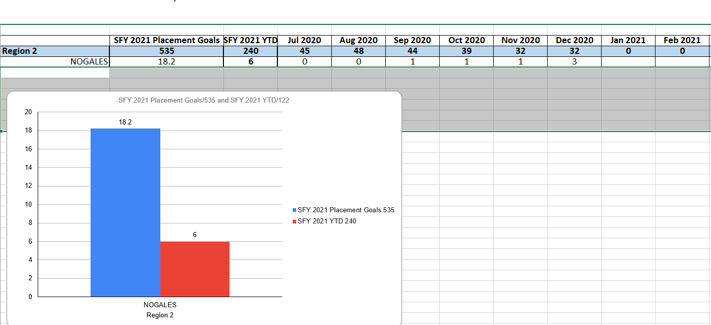
Closures
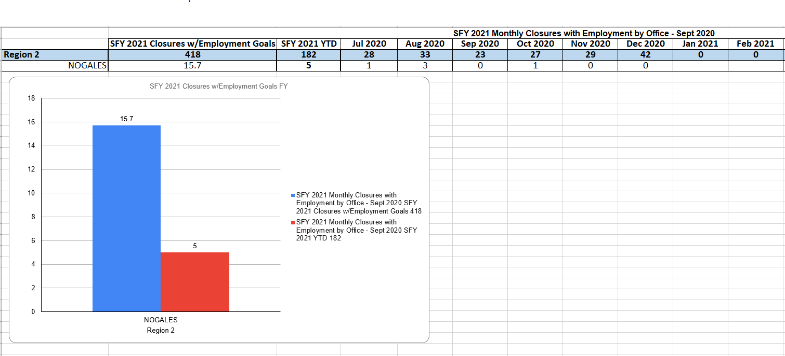

Region II Placements and Closures FY 2019- 2020
Placements
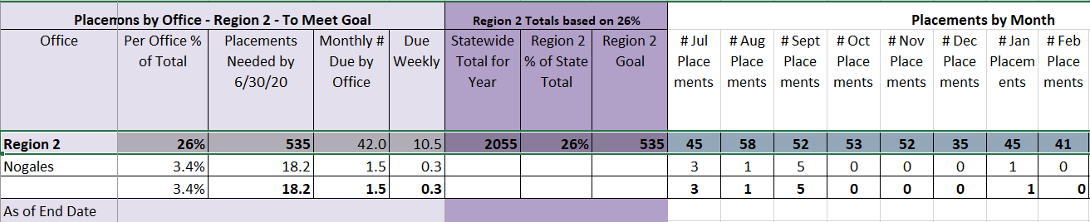

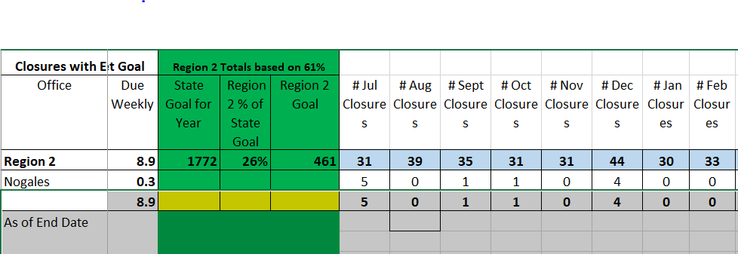

Closures
Comparison summary between FY 2019-2020 and FY 2020-2021:
Vocational Rehabilitation Services has managed to continue to provide vocational services during these COVID times. The epidemic this year has not related to affecting our Placement and Closure numbers so much, as our numbers are in range of meeting our goals, and we still have 4 more months of work to complete before the end of this year. I would say that we are close to the same number of Placements and Successful closures as we have been in previous years. Other factors I would like to include are that we have had only 1 VR Counselor for the last 2 years serving all the clients in the greater Nogales region, but now we have hired another VR Counselor to our Nogales team who will increase our numbers even further by focusing on serving our DDD clients and Transition School to Work clients in High School. ______________________________________________________________________________
Nogales VR Office Updates:
- We continue to provide client services virtually using phone, email, Google Meets and ZOOM.
- Training new staff person continues who serves the transitional school to work youth in Santa Cruz County.
- Partnerships with BH agencies and schools in Nogales continue/ looking to expand to Rio Rico and Patagonia.
- Outreach efforts are a priority to generate new referrals; scheduling presentations and guest speakers.
- Focusing on community partnerships and tracking cross referrals between WIOA Title partners.

H. One Stop Operator – Jim Mize

- Zoom meeting was held with Core Partners which included Adult Education, Vocational Rehabilitation, and Employment Services and WIOA and are hoping to include other agencies like PPEP, Job Corps, Eques. Talked about a client tracking system and hoping to get Dan Sullivan from Pima County to make a presentation. Job Description was sent about maybe helping SCC hire a Business Services position. Goal for J. Mize is to come down to Nogales and go around to meet business representatives and staff at the One Stop. J. Mize advise that he also got the contract for OSO for the Nineteen Tribal Nations. Is now serving as OSO for Pima, Santa Cruz, Southern Cochise and now the Nineteen Tribal Nation.

I. Presentation: - “WIOA Local Workforce Development Board 101”

J G. Loyola presented a brief presentation to SCC LWDB Members on “WIOA LWDB 101.”
Information provided was a brief description on Board Member functions as LWDB members and their responsibilities. M. Cervantes also thanked entire LWDB for taking the time to be a part of SCC LWDB and dedicating their time to be present and be a part of making a difference for SCC ARIZONA@WORK.

J. Nomination Process:-
Nomination forms together with list of eligible nominees have been emailed to all the LWDB to be completed by Friday, March 12, 2021.

K. Board Reports: New Members Introductions:

- R. Brennen – Nothing to report but would like to ask a few questions after meeting.
- L. Doyle: New real estate sales are going up in the county. 85% are new starts in Rio Rico & Tubac areas.
- V. Cardenas- Nothing to report.
- K. King – Apprenticeship programs are being conducted thru hybrid and zoom. There has been unemployment but soon job opportunities will be coming.
- O. Kramer – Nothing to report.
- N. Lucero – Nothing to report.
- T. McAlpin- Domestic Violence is hitting Santa Cruz County really hard just like in all of the country due to the fact of having to be in closed quarters. SCC county has 75
- D. Sanchez – Nothing to report.
- O. Villa – Nothing to report. Very grateful in getting the opportunity to be a part of this Board and looking forward to learning more.

L. Next Meeting – May 12, 2021 via Zoom at 12:00 noon

M. Adjournment
- L. Doyle motioned to adjourn the meeting, seconded by D. Sanchez and unanimously approved. The meeting adjourned at 1:13 p.m.

